**Groovy Assignment**

**First Groovy program**

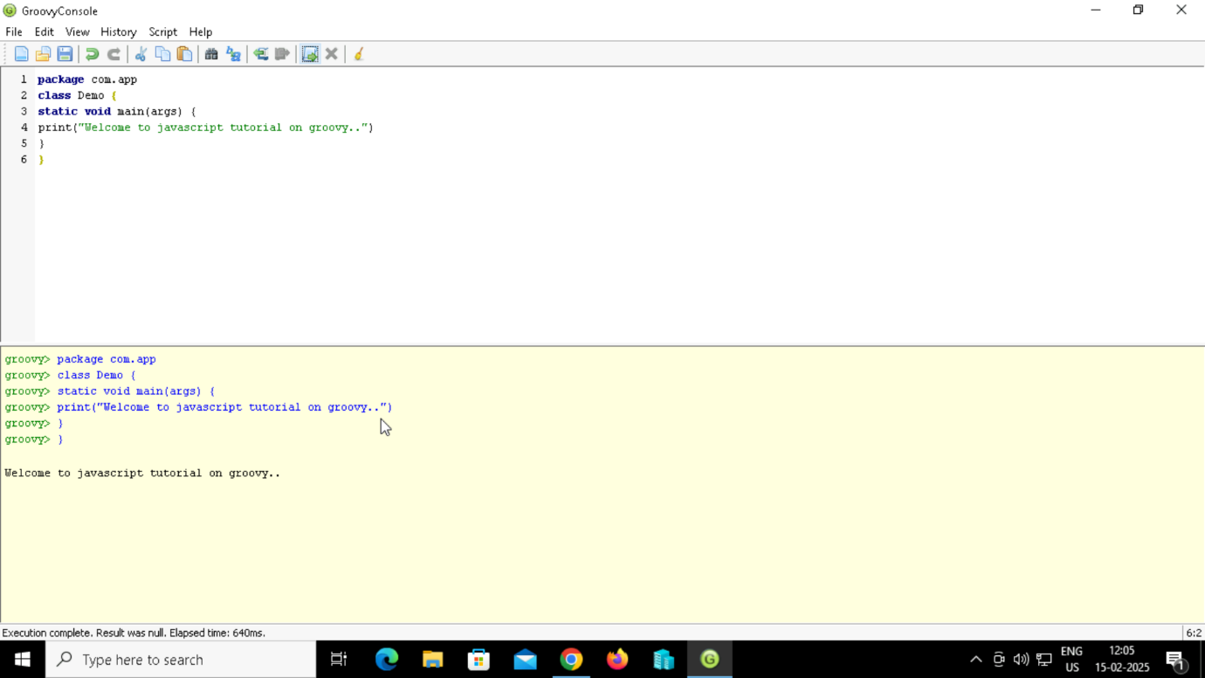

**Basic Syntax in groovy**

**Example 1**

**Example 2**

**Example 3**

**Example 4**

**Arithmetic Operators**

**Example 1**

**Example 2**

**Unary Operators**

**Example 3**

**Example 4**

**Assignment Arithmetic Operators**

**Example 5**

**Relational Operators**

**Example 6**

**Logical operators**

**Example 7**

**Example 8**

**Example 9**

**Bitwise operators**

**Example 10**

**Example 11**

**Conditional operators**

**Example 12**

**Example 13**

**Example 14**

